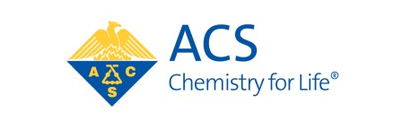

**ANNOUNCING**

**NEW DEADLINE DATES FOR**

**STANLEY C. ISRAEL REGIONAL AWARD**

**FOR ADVANCING DIVERSITY IN THE CHEMICAL SCIENCES**

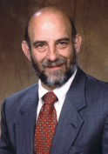

The Stanley C. Israel Regional Award recognizes individuals and/or institutions that have advanced diversity in the chemical sciences and significantly stimulated or fostered activities that promote inclusiveness within the region. For more information on this award, visit our website at [www.acs.org/diversity.](http://www.acs.org/diversity)

**2017 DEADLINES**

**March 1**

CERM, MARM, GLRM, NORM

**August 1**  
MWRM, SERMACS, SWRM, RMRM

**American Chemical Society**

1155 Sixteenth Street, N.W. Washington, D.C. 20036 **T** 202-872-4600 **F** 202-776-8003 www.acs.org