 | 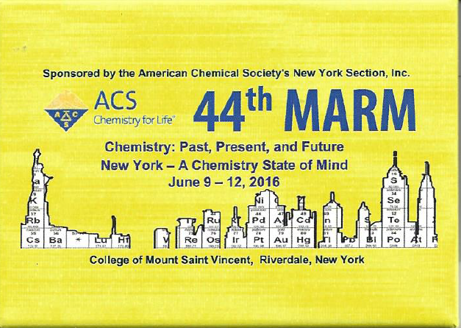

MARM 2016
EXHIBITION RAFFLE PASSPORT
1 |  |  | 17. |  | 
2 |  | 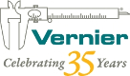 | 18 |  | 
3 |  |  | 19 |  | 
4 |  |  | 20 |  | 
5 |  |  | 21 |  | 
6 |  |  | 22 |  | 
7 |  |  | 23 |  | 
8 |  |  | 24a |  | 
9 |  |  | 24b |  | 
10 |  |  | 25a |  | 
13 |  |  | 25b |  | 
14 |  |  | 26 |  | 
15 |  |  | 27 |  | 
16. |  |  | 28 |  | 

NAME: _______________________________________
PHONE: ______________________________________
EMAIL ADDRESS: ______________________________

Visit the MARM sponsors, receive a stamp from at least 23 booths. Turn in your form at the box at the refreshment booths to be entered to win. Turn in your passport with any number of stamps for an additional drawing.
Drawing will be held on June 11 at 4:30 PM. You do not need to be present to win.

RAFFLE PRIZES
Completed Passports
TCI T-shirt
Periodic Table Blanket
$50.00 Amazon Gift Card

First 250 submitted passports
Turn in your MARM Exhibition Passport at St. John's University's Booth for a laminated periodic table.

RULES
1. You must be present to have your passport stamped. No exceptions.
2. Only one passport per person please.
3. You must have your own name on your passport to have it stamped. We may ask for ID.
4. Participants must be 18 years of age.
5. Prizes will need to be picked up at MARM, or arrangements will have to be made after the meeting.
6. Have a great time!

