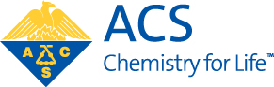

The E. Ann Nalley Regional Award

for Volunteer Service to the American Chemical Society
To be presented at MARM 2011 (www.marmacs.org/2011)

SUPPORT FORM

Deadline: February 12, 2011
Note: Any individual, except a member of the award selection committee, may nominate or support only one nominee for this award in any given year. Please complete all fields.
Submittal: Please complete this form and forward to Christopher Hollinsed, chollinsed@gmail.com
Directions: Click on the gray boxes below and type or paste in content.

Region: Middle Atlantic Region
Date:

NOMINEE INFORMATION
First Name:
Last Name:

SUPPORTER INFORMATION
First Name:
Middle Initial:
Last Name:
Company or Institutional Affiliation:
Present Position (Exact Title):
Address:
City:
State:
Zip:
Country:
Telephone:
Fax:
Email:
RECOMMENDATION
In the space below, paste or type a brief narrative summary describing how you know the nominee and the basis for your support of this nomination.

