The E. Ann Nalley
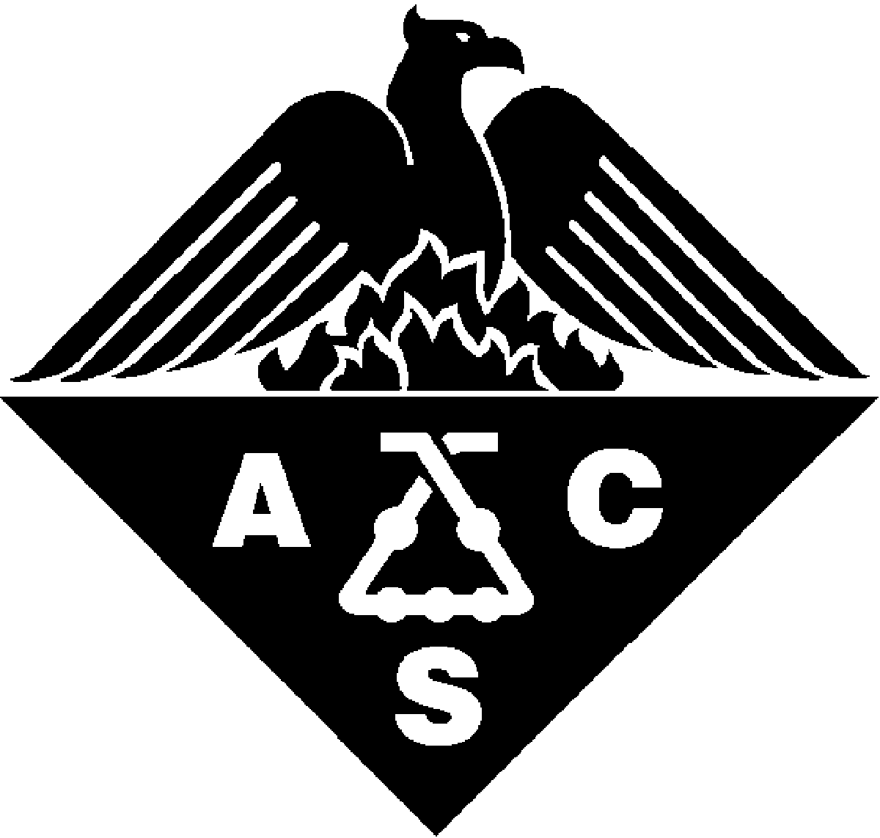

Regional Award for Volunteer Service

to the American Chemical Society

NOMINATION FORM

Deadline: March 1st, 2008
Directions: Any individual, except a member of the award selection committee, may nominate or support only one nominee for this award in any given year. Please complete all fields.
Submittal process: Submit each of the following: nomination and support forms, and biographical sketch (or curriculum vitae) to Dr. Don Mencer (don_mencer@yahoo.com).

Region:

Date:

NOMINATOR INFORMATION
First Name:
Middle Initial:
Last Name:
Company or Institutional Affiliation:
Present Position (Exact Title):
Address:
City:
State:
Zip:
Country:
Telephone:
Fax:
Email:

NOMINEE INFORMATION
First Name:
Middle Initial:
Last Name:
Local Section:

Company or Institutional Affiliation:
Present Position (Exact Title):
Address:
City:
State:
Zip:
Country:
Business Telephone:
Home Telephone:
Fax:
Email:
Website:

Has this nomination been discussed with the nominee? Yes No

Recommendation
In the space below, paste or type a narrative summary evaluating the nominee’s volunteer accomplishments and service to the region. Explain why the nominee is being recommended for this award with regard to the stated purposes of the award.

BIOGRAPHICAL SKETCH
In the space below, paste the nominee’s brief biographical sketch (or curriculum vitae).

Support FORMS

Support forms are being requested from the following individuals (No more than two will be accepted).

Name, Affiliation, Telephone, Email

1.

2.

Submittal process: Submit each of the following: nomination and support forms, and biographical sketch (or curriculum vitae) to Dr. Don Mencer (don_mencer@yahoo.com).
Deadline: March 1, 2008.

